Standardized Protocol for Soil Health Estimation using Latent Variables
Author: Jasper Wubs

Introduction and rationale
This protocol presents the operationalization of the approach outlined in Wubs (2024).For the purposes of this protocol and associated studies, soil health is defined as the condition of a soil which sustains its long-term function and ability to provide ecosystem services, relative to its soil quality, as set by natural and managed ecosystem boundaries (ISO doc). The health of a soil is expressed relative to its theoretical capability set by its soil quality, which is defined as the maximum capability of a type of soil, within natural or managed ecosystem boundaries, to function and provide ecosystem services. The theoretical upper limit is set in practise by quantile regression methods across many soil samples from the same soil type or across soil types. Thus, soil health is a percentage of the theoretical maximum set by a soil type’s soil quality (100%) and it pertains to the functions a soil can perform, particularly in terms of the ecosystem services relevant for humankind. Thus, here, soil health is equal to soil multifunctionality of a soil and its expected ability to keep performing at this level over the long term (decennia to centuries).

This standardized soil health assay addresses the key soil functions in the functional land management framework (Schulte et al., 2014). The method is based on incubations of intact soil cores, subjected to several treatments and measuring responses that are indicative of the underlying soil functions (Fig. 1). The methods assume that all soils are sampled in the same way and incubated under standardized conditions, including temperature, light, watering regime, and air humidity, to ensure comparability (see Table 2). The goal is to estimate the intrinsic capacity of each soil for performing each soil function. Soil health and multifunctionality is then primarily expressed as a multivariate index, with a numerical value for each of the measured functions. If and when these functional scores correlate well across soils we can discuss whether a single aggregate statistic is meaningful to implement.

The collected data are used to parameterize four laten variable models, one for each function, and the scores of the latent are taken as the benchmarked index value for that function. For each function at least 4 indicators have been identified to serf as the indicators to condition the latent variable on.

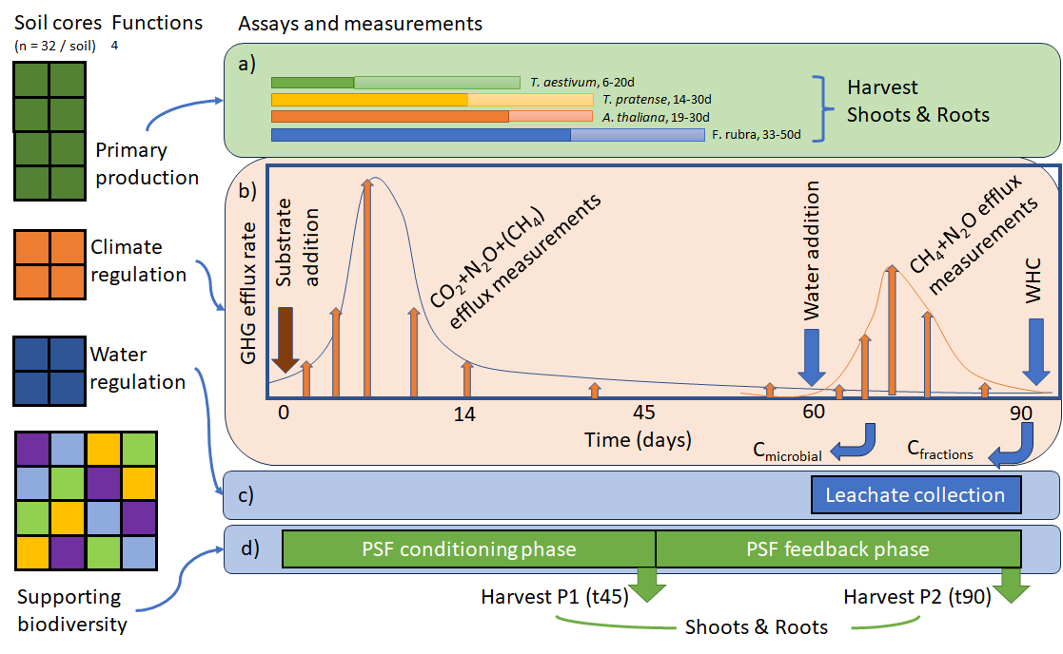

Figure 1: Design diagram of the soil function measurement setup, version 0.1.
A soil sampling team will collect 32 soil monoliths (60 mm x 25 cm deep, ~22.6 L soil) per soil and/or field. The monoliths are used to quantify primary production (a) 8 green monoliths, 2 per bio-assay plant species, climate regulation (b) 4 orange monoliths, one for each substrate addition treatment, water regulation (c) 4 blue monoliths, for water storage and purification measurements and for supporting plant biodiversity (d) 16 coloured monoliths, each colour represents an indicator plant for which direct and indirect plant-soil feedback is estimated phase 2 (P2) on each of four soils conditioned during phase 1 (P1). The monoliths are incubated for 90 days under standard incubation conditions (Table 2). As such the measurements target the capacity of a soil to deliver key soil functions under optimal conditions for plant growth. For both primary production and biodiversity functions plant harvest days are fixed and based on plant dry mass. Likewise, upon substrate addition (t0) gaseous efflux of CO₂, N₂O and CH₄ are measured on fixed days, with intensive sampling in the first 14 days, and then less frequent sampling until day 90. In addition, microbial C and C in soil fractions (aggregates) is measured after 70 and 90 days. The water regulation measurements can be done independently in this setup and can potentially be shifted in time, but are now placed at the end of the 90 day period to spread the workload over time. However, infiltration and leaching measurements will be conducted over a fixed time period.

Materials

Table 1. Required materials for field sampling and processing in the greenhouse (per sampled field). Items that are strictly necessary are indicated with an ‘x’.
Material | Description | Strictly
Field sampling
Containers per soil | 32 soil cores = containers | x
Container | PVC tube, diameter 60 mm x 25 cm deep (707 cm3) | x
Soil corer | Gouge augur, 60 mm diameter, >25 cm long
Hammer
Knife | Sharp | x
Brush | Sturdy | x
Sticks | 4 for a plot, take 8 or 12 if you work with multiple people | x
GPS | Preferably a dedicated GPS, but a decent smartphone can do the job | x
Sampling sheet | 1 per soil/field | x
Incubation
Dispensator | Able to repeatedly dispense 20 mL
Potting soil | 3 * 32 cores = 96 cores for internal benchmark  type | X
Control sand | 3 * 32 cores = 96 cores for internal benchmark  ISO 679:2009(en); https://www.iso.org/standard/45568.html) | x
Primary production assay
Seeds | - Festuca rubra  - Trifolium pratense  - Arabidopsis thaliana  - Triticum aestivum  8 seeds per species and per soil/field + potting soil + control sand | x
Bags | Paper | x
Climate regulation assay
Substrates | - Sawdust (C/N >100) [amount 4.0 t/ha equivalent]  - Legume (common bean, C/N ~20-25).  - Farmyard manure (C/N ~30-40)  - Control | x
Headspace chambers | 6 cm diameters, 10 cm high.  Airtight | x
Exetainer | Airtight | x
Syringe | Airtight | X
Water regulation assay
Disperser | Set to 10 mL
Syringe | Capable of 1 mL droplets | x
Suction cups |  | x
Pollutants | - Nutrients: NO₃ + PO₄  - Heavy metals: Cd + Pb  - Pesticides: Glyphosate + Fluopyram | x
Supporting biodiversity assay
Seeds | Species – Rutger  8 seeds per species and per soil/field + potting soil + control sand | x
Bags | Paper | x
Analytical machinery
Oven | Needs to go to 70 °C | x
Balance | To 0.001 g accuracy | X
Balance | To 0.1 g accuracy | x
Gas chromatograph | Capable of measuring CO2, N2O, and CH4. | Outsource?
CN analyser |  | Outsource?
AutoAnalyzer |  | Outsource?
HPLC |  | Outsource?
FAAS |  | Outsource?

Step-by-step instructions
Field sampling
Collect 32 soil monoliths (60 mm x 25 cm deep, total ~22.6 L soil per field) per soil and/or field.
- Setup a randomly selected 2x2 m plot using sticks and record the position of the NW corner using handheld GPS. Add a brief description of each plot in the sampling sheet.
- Insert the soil augur to 25 cm depth and place each monolith in a separate container.
  - Try a new spot if you hit a rocks along the way
- Label each core with a code for the field/soil and for each (replicate) core.
- Cut the vegetation of the top of each container and remove protruding roots
- Clean the augur regularly using a brush; no need for ethanol rinsing - this is a dirty method.
- Transport the cores to the lab as cooly as possible, but no need for a cool container – you will likely have to many cores anyway.

Incubation setup
The sampled cores are incubated for 90 days in a common environment, typically a greenhouse or a growth cabinet, under standard conditions (Table 2). As such the measurements target the capacity of a soil to deliver key soil functions under optimal conditions for plant growth. The guidelines under the table 2’s ‘strict’-column are an absolute necessity, while the items under ‘preferable’ are strongly recommended, but not strictly necessary.

The cores are used to quantify primary production using four bio-assay plant species, climate regulation, using four substrate addition treatments, water regulation - split into water storage and purification measurements - and for supporting plant biodiversity with four indicator plant species for which direct and indirect plant-soil feedback is estimated in phase 2 (P2) on each of four soils conditioned during phase 1 (P1).

Steps
- Start the incubation after a 14-28 days resting period upon field sampling. Record the dates.
- Set the greenhouse/growth cabinet to the required conditions (Table 2).
- Prepare the potting soil and control sand internal benchmarks for your experiment by filling 96 (i.e. 3 replicates) cores with potting soils and 96 with the control sand.
- Sow each of the plant seeds into the correct containers. See under primary production and supporting biodiversity for details.
- Place the 32 containers for each soil in a block next to each other, but randomize the blocks in space in the greenhouse/growth cabinet.
- During the incubation water the cores three times per week using 20 mL water each time using a dispensator.
- Whenever possible record the fluctuations in the incubation conditions (Table 2).

Table 2. Standardized incubation conditions and mesocosm setup.
Factor | Settings
 | Strictly needed | Preferable
Light | 16:8 h day:night | 225 µmol light quanta m⁻² s⁻¹ at plant level
Temperature | 26.5° ±2°C (mean ±SD)
Relative air humidity | Not too dry | 31% ± 8%.
Watering | Add 20 mL water 3 times per week; Monday, Wednesday, Friday.

Soil function measurements

Primary production
For primary production, we follow the method developed by Daou and Shipley (2019).

- Plant seeds of each species into the correct containers.
- Use four seeds per pot
- Incubate the plants under the standard conditions in the greenhouse or growth cabinet for a pre-specified and fixed number of days per plant species
- Clip the shoot biomass of 2 randomly selected individuals per container on the specified days.
- The harvest days are:
  - Triticum aestivum, 6 and 20 days after starting the incubation.
  - Trifolium pratense, 14 and 30 days.
  - Arabidopsis thaliana, 19 and 30 days.
  - Festuca rubra, 33 and 50 days.
- Dry the cuttings at 70 C for minimum 48h and weigh them on a balance. Note the dry weights down.

Climate regulation
The setup is based on the input of four types of substrates to the containers and measuring the response in terms of greenhouse gas (CO2, N2O, CH4) emissions. Substrates are to be supplied at the equivalent of a 4.0 t/ha input rate. In addition, microbial C and C in soil fractions (aggregates) are measured after 70 and 90 days.

- Before field sampling make sure that you have enough of each substrate
  - Sawdust (C/N >100)
  - Legume (common bean, C/N ~20-25).
  - Farmyard manure (C/N ~30-40)
  - Control
- Put the substrates on top of the containers and incubate them.
  - 4.0 t/ha equivalent: calculations
- On prespecified days take a gas headspace using an airtight syringe by putting the headspace chamber on the container and sample after 20 min and store the gas mixture in an airtight exetainer.
- Sampling days after start of the incubation: 1, 2, 3, 7, 10, 14, 30, 60.
- After 70 and 90 days take a soil sample from each container to measure microbial C and C in soil fractions (aggregates).
- Measure microbial C and C in soil fractions (aggregates) using standard protocols.
- Flood the cores with water on day 60 and keep them flooded.
- Sample the headspace at day 61, 62, 63, 67, 70, 74, 90.
- Measure the headspace samples on a gas chromatograph for CO2, N2O and CH4.

Water regulation
For water regulation we measure two subfunctions: water storage and water purification.

Water purification
- On day 60:
- Flush the relevant containers with one of the types of pollutants.
  - Nutrients: NO₃ + PO₄ Add concentrations to add
  - Heavy metals: Cd + Pb
  - Pesticides: Glyphosate + Fluopyram
  - Control
- Collect the leachate of the containers during 30 days (day 60 to day 90).
- Determine pollutant concentrations in the leachate using AutoAnalyzer, HPLC and FAAS.
Water storage
- For water storage, on day 90:
- Place four water droplets with a syringe on soil surface and measure time to penetration for each droplet.
- Add a fixed volume of water (10 mL) to the containers on top of soil and measure time to infiltration.
- Add water to the correct containers to saturation and lower moisture content using suction cups.
  - Weigh the containers to determine field capacity and wilting point gravimetrically. Follow ISO 11274:2019 when possible.
    - Field capacity: −33 kPa.
    - Wilting point: -1,500 kPa.

Supporting biodiversity

The method is based on the typical plant-soil feedback setup (Van der Putten et al., 2013). We quantify both conspecific feedback and the heterospecific feedbacks among four plant species.

- Sow the seeds of each species, planting 4 seeds per container.
- Species:
  - TBD
- For phase 1 incubate the plants for 45 days, then clip the shoot biomass of all four plants per container.
- Dry the clipped plants at 70 C for minimum 48h and weigh (to 0.001 g) them on a balance. Note the dry weights down.
- Replant the containers with the four species in a full-factorial design, thus making sure that each species grows on each type of conditioned soil
- Grow the plants for an additional 45 days (phase 2) and subsequently cut their shoot biomass.
- Dry the clipped plants at 70 C for minimum 48h and weigh (to 0.001 g) them on a balance. Note the dry weights down.

Epilogue
Okay, all done – kudos!
You can send the results to info@SoBiFUN.eu.

References
Daou, L. and Shipley, B.: The measurement and quantification of generalized gradients of soil fertility relevant to plant community ecology, Ecology, 100, e02549, https://doi.org/10.1002/ecy.2549, 2019.
Schulte, R. P. O., Creamer, R. E., Donnellan, T., Farrelly, N., Fealy, R., O’Donoghue, C., and O’hUallachain, D.: Functional land management: A framework for managing soil-based ecosystem services for the sustainable intensification of agriculture, Environ. Sci. Policy, 38, 45–58, https://doi.org/10.1016/j.envsci.2013.10.002, 2014.
Van der Putten, W. H., Bardgett, R. D., Bever, J. D., Bezemer, T. M., Casper, B. B., Fukami, T., Kardol, P., Klironomos, J. N., Kulmatiski, A., Schweitzer, J. A., Suding, K. N., Van de Voorde, T. F. J., and Wardle, D. A.: Plant–soil feedbacks: the past, the present and future challenges, J. Ecol., 101, 265–276, https://doi.org/10.1111/1365-2745.12054, 2013.
Wubs, E. R. J.: Benchmarking soil multifunctionality, EGUsphere, 2024, 2851, https://doi.org/doi.org/10.5194/egusphere-2024-2851, 2024.

